TASK ON AMAZON EC2

- Launch one EC2 using Amazon Linux 2 image and add a script in user data to install Apache.
- Login amazon EC2 console
- Search for EC2→ Open EC2 Dashboard
- Click Launch Instance
- Name: AmazonLinux-Apache
- AMI: Select Amazon Linux 2.
- Instance Type: t2.micro (Free tier eligible)..
- Key Pair: Create or select existing
- Add User Data Script
- Scroll to Advanced Details → User Data.
- Paste below script:
- #!/bin/bash
- yum update -y
- yum install httpd -y
- systemctl start httpd
- systemctl enable httpd
- echo "Apache Installed Successfully" > /var/www/html/index.html

Configure Security Group
- Allow HTTP (Port 80)
- Allow SSH (Port 22)
Launch Instance
- Click Launch.
- Copy Public IP → Open in browser → Verify Apache page

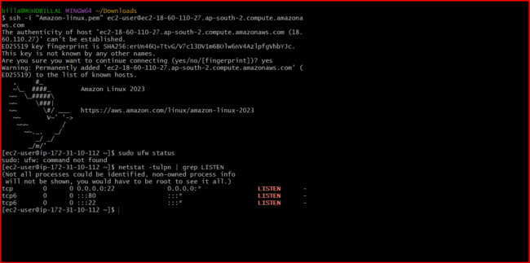
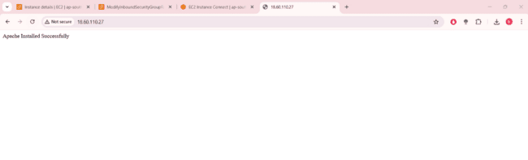
- Launch one EC2 using Ubuntu image and add a script in user data to install Nginx.
- If a new user is added in our group and we did’t want to provide the full access like root sudo then we take new user ssh-keygen key and placed that key in the .ssh// then authorised_key placed that key there
Step 1: Launch Instance
- EC2 → Launch Instance.
- Name: Ubuntu-Nginx
- AMI: Ubuntu Server.
- Instance Type: t2.micro.
- Select Key Pair.
Step 2: Add User Data Script

#!/bin/bash
apt update -y
apt install nginx -y
systemctl start nginx
systemctl enable nginx
Step 3: Security Group
- Allow HTTP (80)
- Allow SSH (22)
Step 4: Launch → Check Public IP in browser.

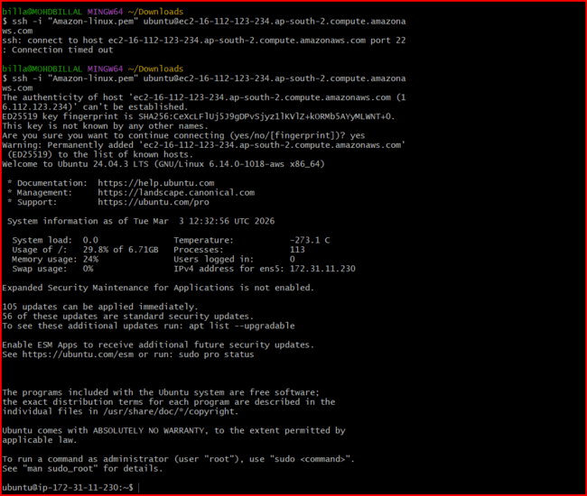

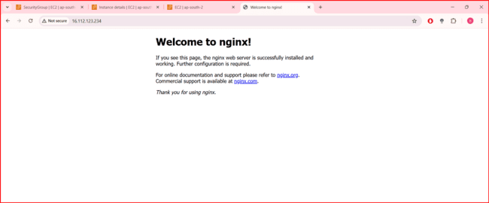
- Launch one Windows server and install Tomcat on Windows.
Step 1: Launch Windows Instance
- EC2 → Launch Instance.
- Name: Windows-Tomcat
- AMI: Windows Server 2019/2022.
- Instance Type: t2.micro or t3.micro.
- Allow RDP (3389).
Step 2: Connect to Windows
- Select Instance → Connect → RDP Client.
- Download RDP file.
- Get Administrator Password using key pair.

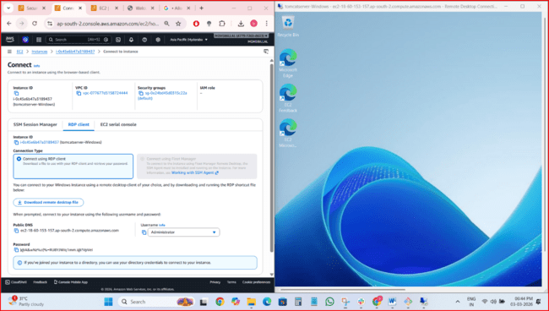
- Step 3: Install Java
- Download JDK from Oracle website.
- Install and set JAVA_HOME.
- Step 4: Install Apache Tomcat
- Download Tomcat zip.
- Extract → Open bin folder.
- Run startup.bat.
- Open browser:

I have connected to the instances and there is a hostname, instanceID, public address , zone etc
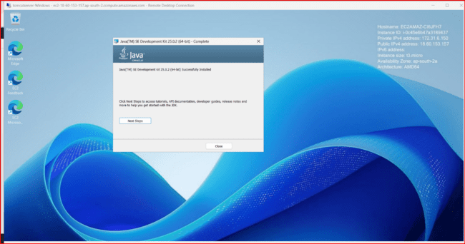

I have downloaded and installed the tomcat in that instance and it is running in the default port number 8080
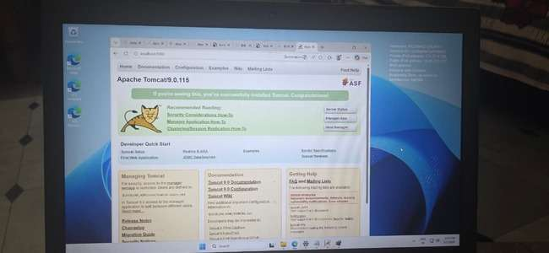

Before that I have configure the inbound rules for the instances and connecting
Assigning the port numbers like 8080
Search firewall in the setting and go

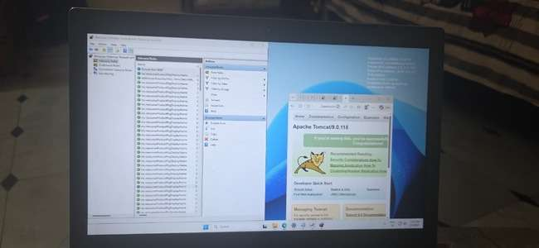
- Take a snapshot of the instance created in Task 1.
Step 1:
EC2 → Instances.
Select AmazonLinux-Apache instance.
Step 2:
Storage tab → Click Volume ID.
Step 3:
Actions → Create Snapshot.
Provide name → Create.
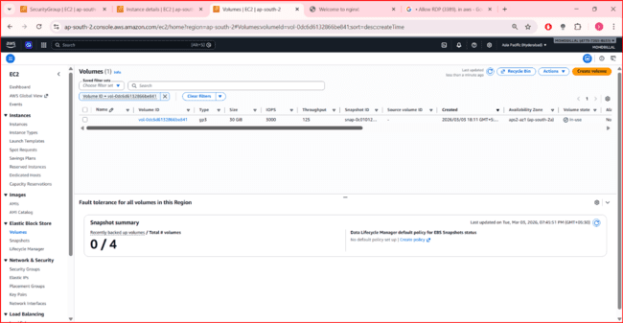

- Assign passwordless authentication for the EC2 created in Task 2.
Step 1: Connect to Instance
ssh -i key.pem ubuntu@public-ip
Step 2: Generate SSH Key
ssh-keygen

cat ~/.ssh/id_rsa.pub >> ~/.ssh/authorized_keys
Now password Less authentication enabled.

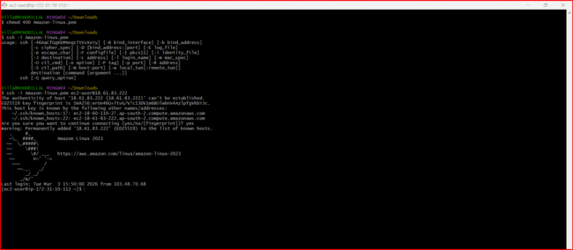
- Launch any EC2 using the spot purchasing option.
Step 1:
EC2 → Launch Instance.
Step 2:
Expand Advanced Options.
Purchasing Option → Select Spot Instance.
Step 3:
Launch Instance.

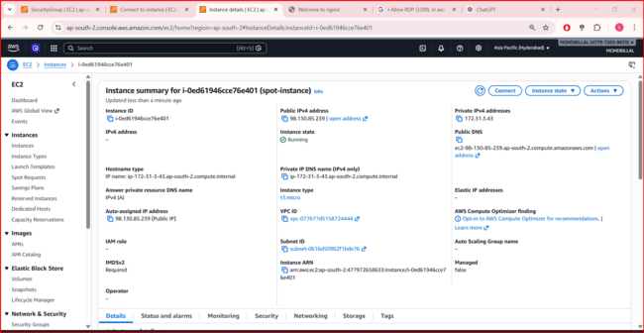

- Enable termination policy on the EC2 created in Task 2.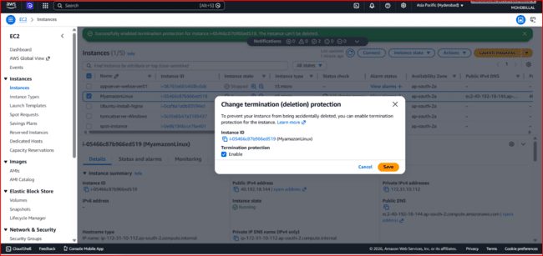
Step 1:
- EC2 → Instances.
- Select Ubuntu instance.
Step 2:
- Actions → Instance Settings → Change Termination Protection.
- Enable → Save.

- Launch one EC2 using AWS CLI.
Step 1: Install AWS CLI
Windows: Download from AWS site.
Linux:
sudo apt install awscli
Step 2: Configure AWS CLI
Bash/git bash - aws configure
Enter Access Key
Secret Key
Region (example: ap-south-1)
Output format: json

